**How to request in PPM**

**Document History**

|  |  |  |  |
| --- | --- | --- | --- |
| **Version number** | **Update by** | **Date** | **Remarks** |
| V.1.0 | Mithun Chakrovarty | 10 August 2016 | Initial Document Prepared |
| V.1.2 | Mithun Chakrovarty | 16 April 2018 | Modified |

**Step 1:** Go to the PPM site **http://ppm.valmet.com/**

Go to the **REQUEST** 🡪 **Make request** tab.

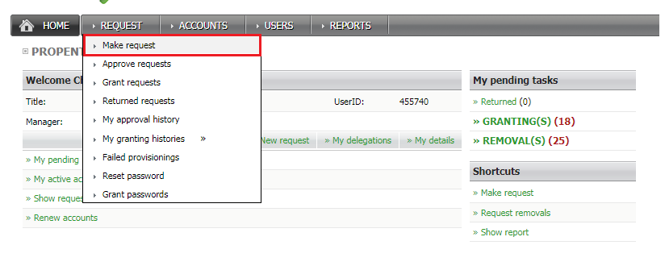

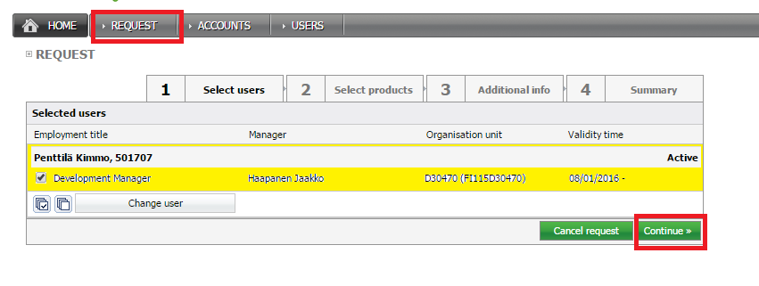

Select Request button for Expected user (which user are want to request for PDM)

**To Create a New PDM Account**

For new user creation go to the following path

[**Valmet**](javascript:selectProductFolder(35))🡪 [**Common systems**](javascript:selectProductFolder(115))🡪 [**PDM**](javascript:selectProductFolder(183))

To create a new account, you have select following items

1. PDM User ID
2. Business role
3. Owner group
4. Viewing group
5. ERP company
6. Market area

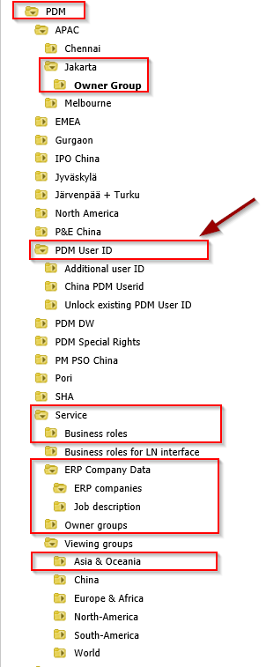

For each segment (Example for **Business roles**) select desire option and click to **Add Selected to cart.**

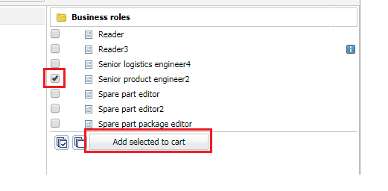

After finishing **Add selected to cart** for all describe options, please click on **continue** button.

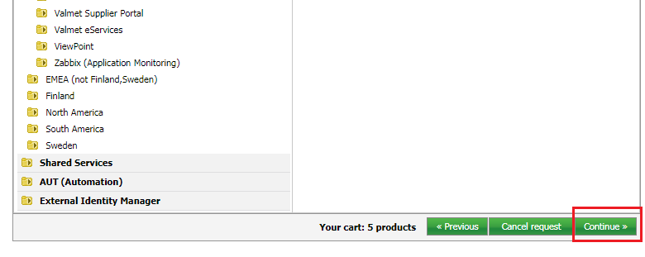

After continue One window will appear. Check your all options if need to more add please go back to your **Previous.** Otherwise go forward using **Continue**.

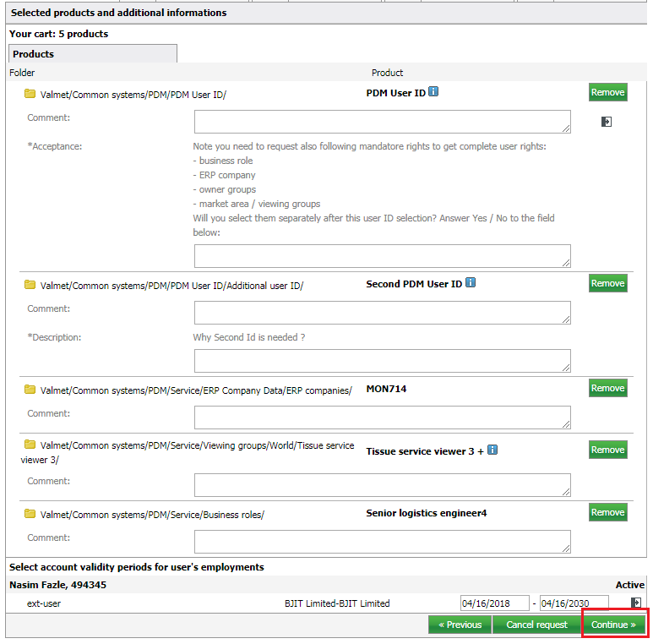

After continue a final window will appear. After Clicking on **Complete request** task is done.

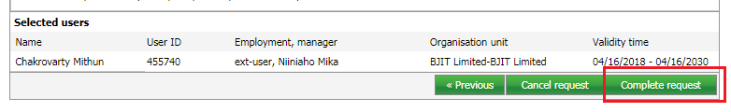

**To get New Owner group Access**

To get a new owner group access, go to the following path

[**Valmet**](javascript:selectProductFolder(35))🡪 [**Common systems**](javascript:selectProductFolder(115))🡪 [**PDM**](javascript:selectProductFolder(183))🡪 **Service🡪 Owner groups**

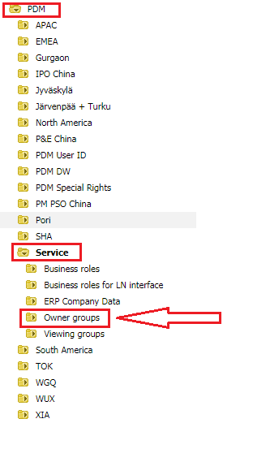

Select your desire **Owner group** and click on **Add Selected to cart.** And also click on **Continue** button

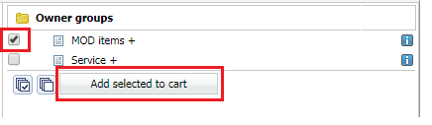

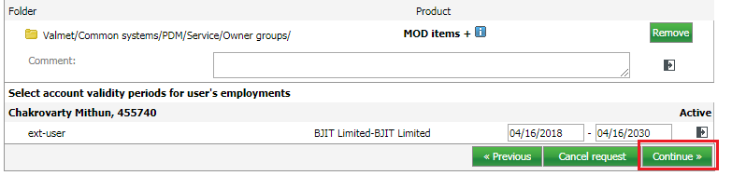

After clicking on **Complete request** the task is over.

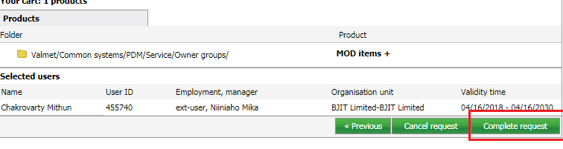

**To get New Viewing group Access**

To get a new **Viewing group** access, go to the following path

[**Valmet**](javascript:selectProductFolder(35))🡪 [**Common systems**](javascript:selectProductFolder(115))🡪 [**PDM**](javascript:selectProductFolder(183))🡪 **Service🡪 Viewing groups**

Select your desire viewing group and click on **Add Selected to cart.** And click on **Continue** button (**Same as Owner group**)

**To get New Business role**

To get a new **Business role**, go to the following path

[**Valmet**](javascript:selectProductFolder(35))**🡪** [**Common systems**](javascript:selectProductFolder(115))**🡪** [**PDM**](javascript:selectProductFolder(183))**🡪 Service🡪 Business role**

Select your desire **Business role** and click on **Add Selected to cart.** And click on **Continue** button (**Same as Owner group**)

**To get New ERP company Access**

To get a new **ERP company**, go to the following path

[**Valmet**](javascript:selectProductFolder(35))**🡪** [**Common systems**](javascript:selectProductFolder(115))**🡪** [**PDM**](javascript:selectProductFolder(183))**🡪 Service🡪 ERP Company Data**

Select your desires **ERP company** and click on **Add Selected to cart.** And click on **Continue** button (**Same as Owner group**)